1. Login Page Re-design.

|  |  |
| --- | --- |
| https://static.vecteezy.com/system/resources/previews/010/153/064/original/check-mark-icon-sign-symbol-design-free-png.png | Working |

1. Graphical representation in dashboard, in future we do more on this.

|  |  |
| --- | --- |
| https://static.vecteezy.com/system/resources/previews/010/153/064/original/check-mark-icon-sign-symbol-design-free-png.png | Updated.  Might need more work based on business needs. |

1. Forgot Password Option added. If anyone forgot his/her password by click forgot password an auto-generated password is sent to his/her email.

|  |  |
| --- | --- |
| https://static.vecteezy.com/system/resources/previews/010/153/064/original/check-mark-icon-sign-symbol-design-free-png.png | Option available. Can be sure after live. |

1. Request is linked with email. If any one raise a request the request is linked with email and his/her approver can easily view this request by clicking request link.

|  |  |
| --- | --- |
| https://static.vecteezy.com/system/resources/previews/010/153/064/original/check-mark-icon-sign-symbol-design-free-png.png | Option available. Can be sure after live. |

1. All menus by default collapse now and single menu click only open it’s sub-menu, Previously single menu click open multiple sub-menu which is bothering.

|  |  |
| --- | --- |
| https://static.vecteezy.com/system/resources/previews/010/153/064/original/check-mark-icon-sign-symbol-design-free-png.png | Working |

1. Running Settlement Summary Table without TA/DA (Rollback Settlement View)  with total column Added.

|  |  |
| --- | --- |
| https://www.pngmart.com/files/17/Wrong-Sign-PNG-File.png | NB-BC-08282023-720  Total calculation in Running Settlement is not okay. |

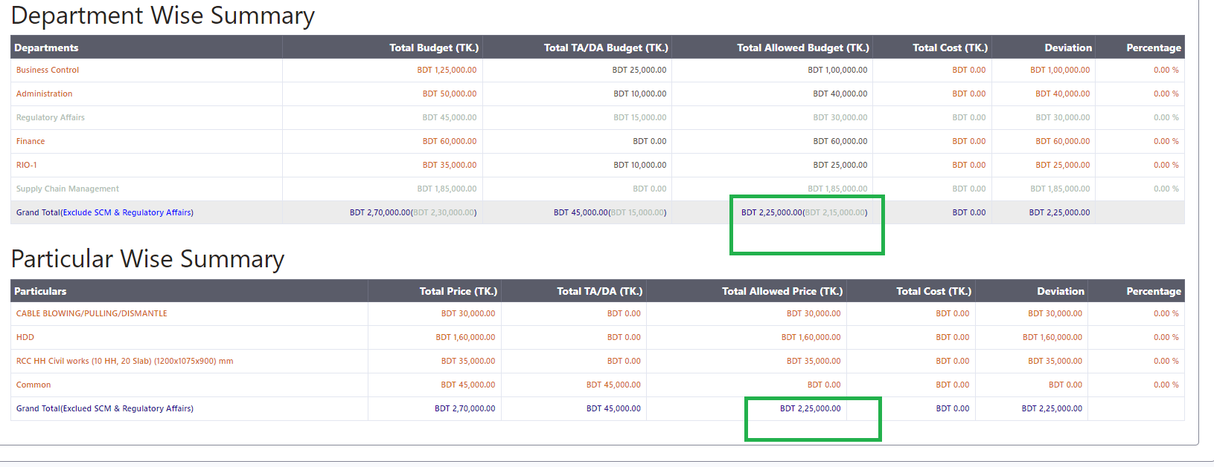

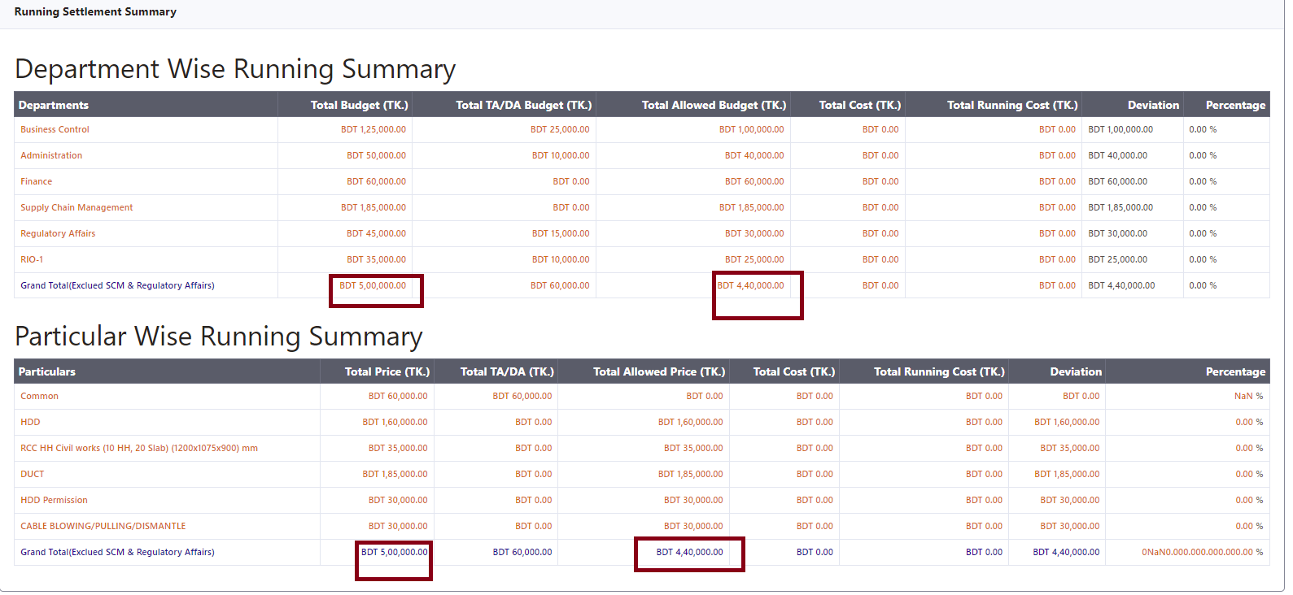

1. RollBack request view Search Option added in approver dropdown list.

|  |  |
| --- | --- |
| https://static.vecteezy.com/system/resources/previews/010/153/064/original/check-mark-icon-sign-symbol-design-free-png.png | Solved. |

1. Item can now added by item code during settlement

|  |  |
| --- | --- |
| https://static.vecteezy.com/system/resources/previews/010/153/064/original/check-mark-icon-sign-symbol-design-free-png.png | Solved. |

1. Attachment is now visible for draft and final submission.

|  |  |
| --- | --- |
| https://www.pngmart.com/files/17/Wrong-Sign-PNG-File.png | NB-BC-08282023-720  But can not remove or change after draft before final submission. |

After Draft: File can not be removed.

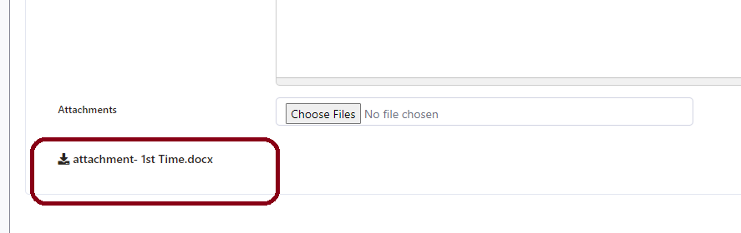

After Rollback: Previous attachments are not visible.

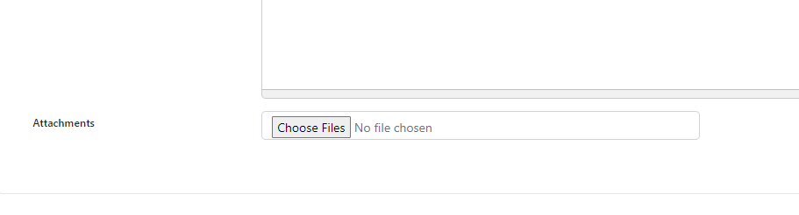

After Resubmission: New attachment is not available but previous attachments are remained.

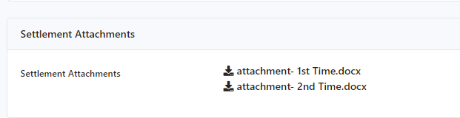

1. Total Line Added at the end of table during settlement entry

|  |  |
| --- | --- |
| https://www.pngmart.com/files/17/Wrong-Sign-PNG-File.png | NB-BC-08282023-720  Total calculation is not okay. Please follow the amount of **Budget Summary View** during settlement entry. |

During Settlement Entry:

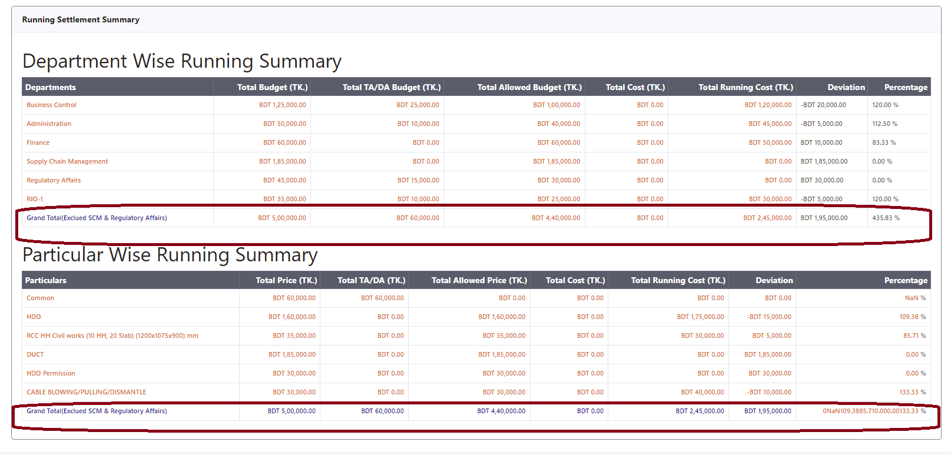

1. **Particular Wise Running Summary and Completed Summary without TA/DA, SCM and CRA**

|  |  |
| --- | --- |
| https://www.pngmart.com/files/17/Wrong-Sign-PNG-File.png | NB-BC-08282023-720  Particularly wise total amount is not accurate. |

Table during settlement approval

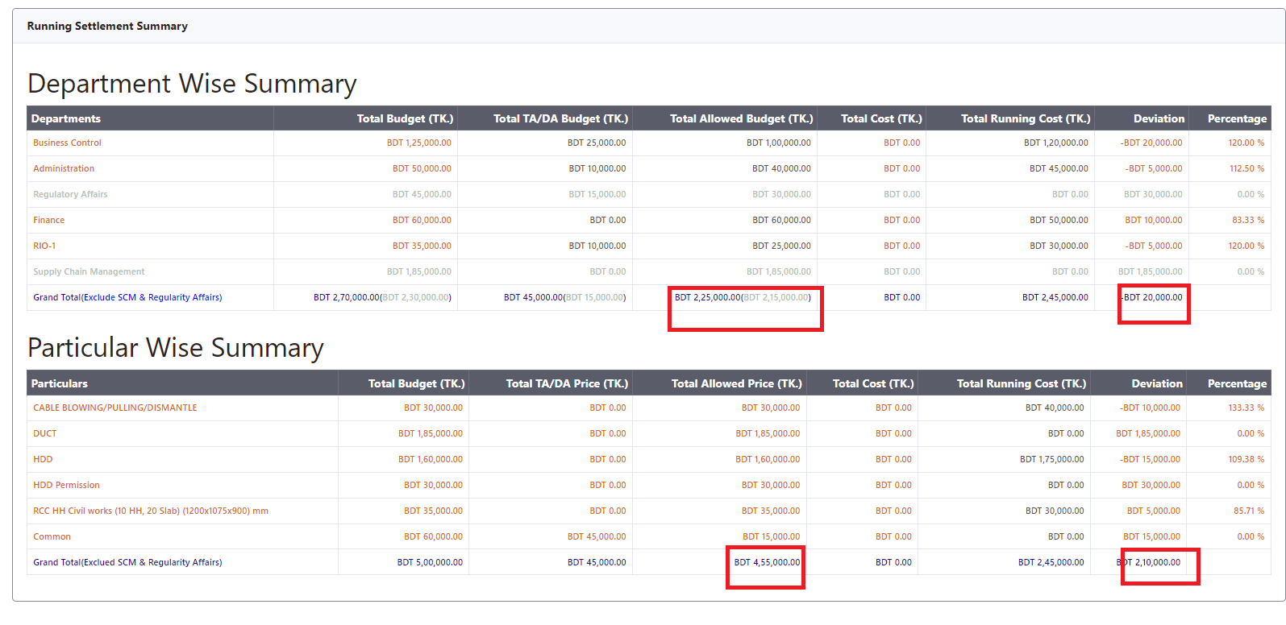

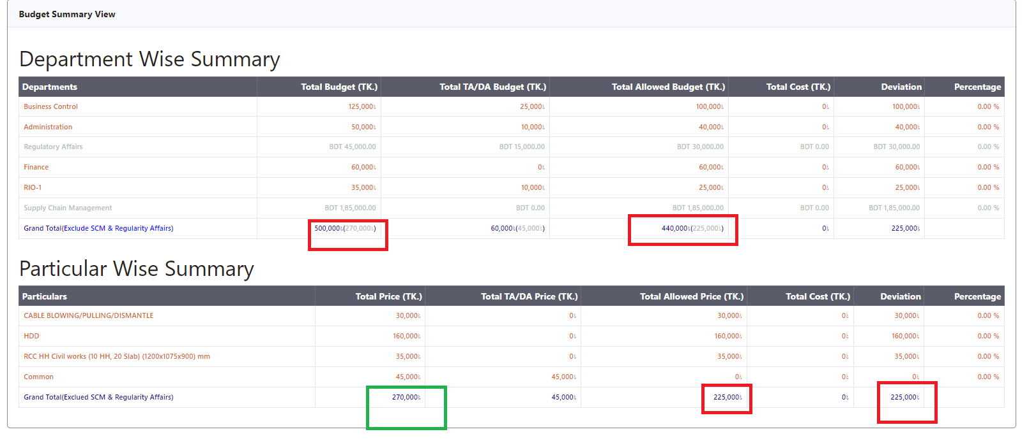

Table after rollback

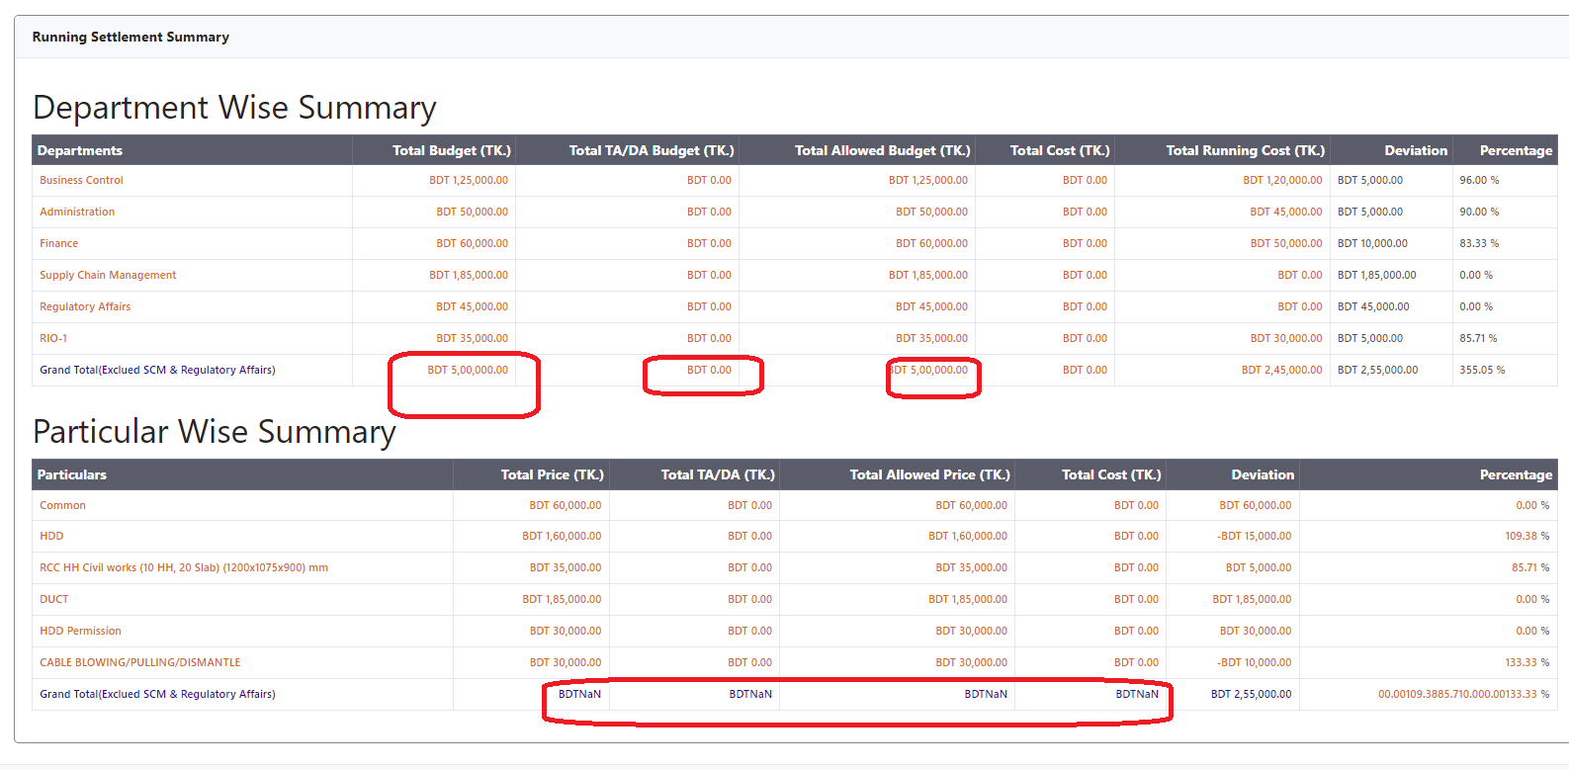

1. Initial memo details total added in department wise summary/ particular wise summary.

|  |  |
| --- | --- |
| https://www.pngmart.com/files/17/Wrong-Sign-PNG-File.png | NB-BC-08282023-720  Memo amount will be **20,000.**  But it is showing 3 different data in UAT (Memo Initiate View). One error in approval view. |

Memo Initiate View

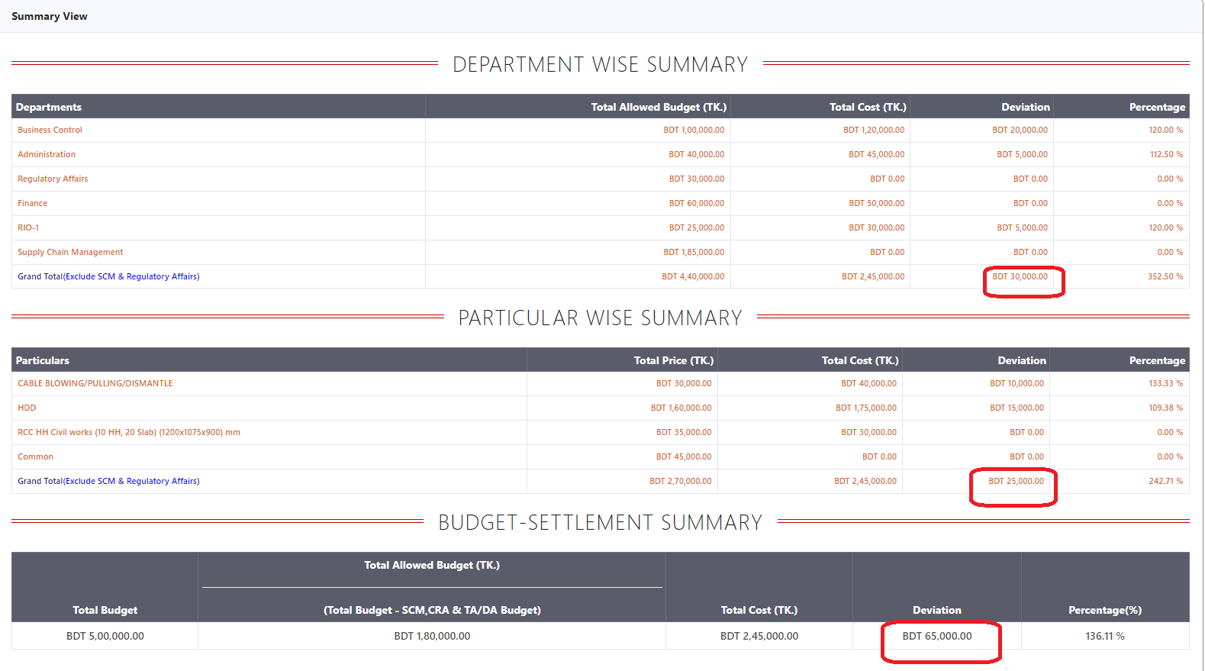

One Error in Memo View after Submission

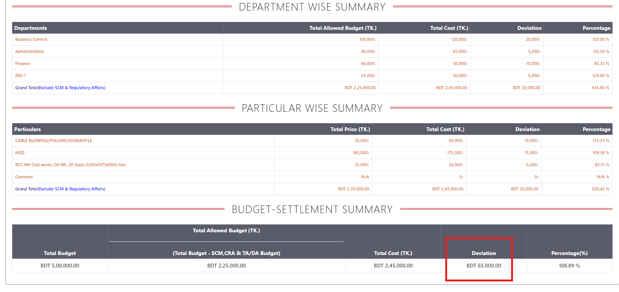

Memo Approval View is not ready  
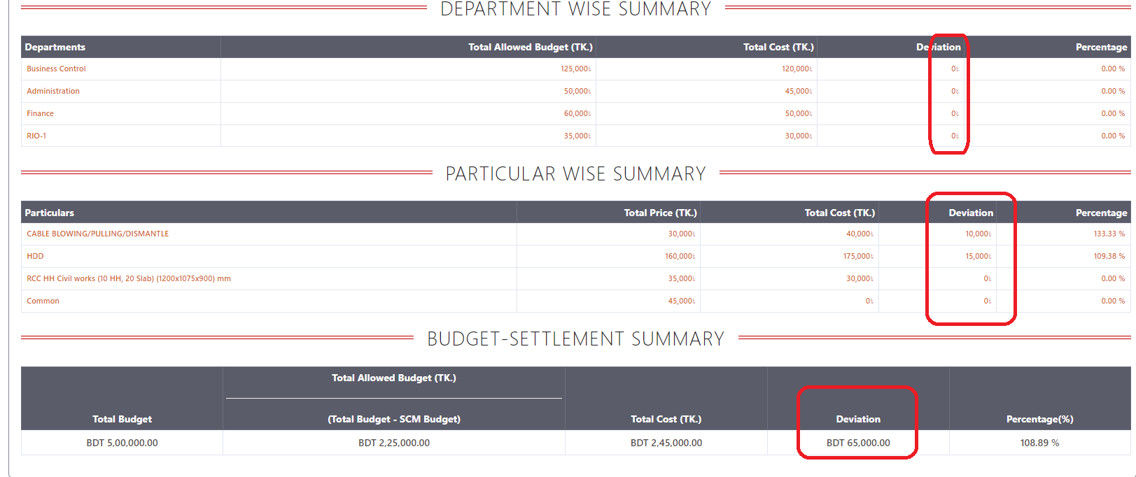

Attachment not available

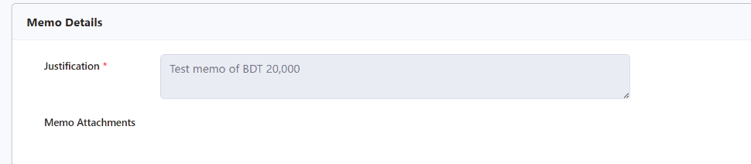

1. Completed Memo details total added in department / particular wise summary.



1. Settlement Data Export to excel for running budget summary.

      Still working for pdf generate for running budget summary.

.